1.Write a C program tp print Hello Student on screen.

Ans.

Source Code:

#include<stdio.h>

main()

{

printf("Hello Students");

}

Output:

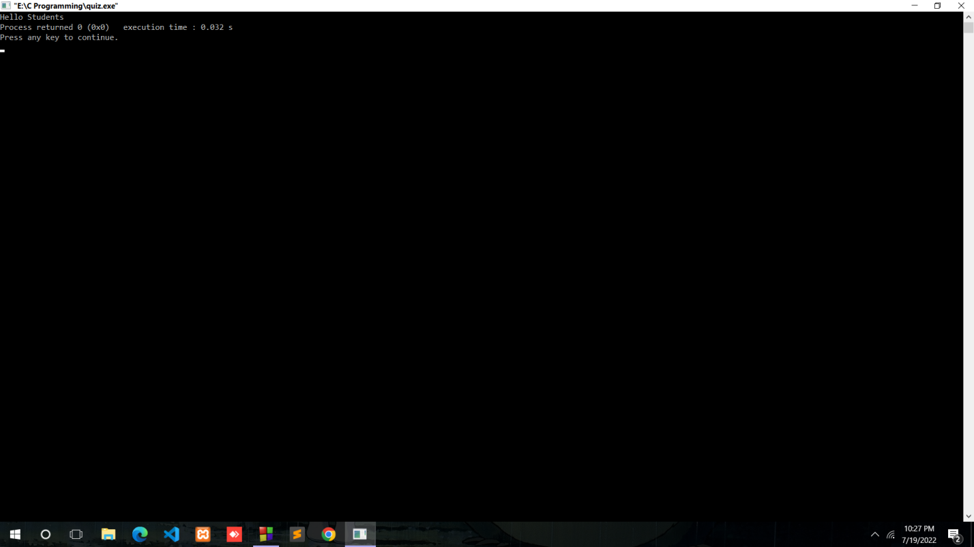

2.Write a C program to print Hello on the first line and Students on the second line.

Ans.

Source code:

#include<stdio.h>

main()

{

printf("Hello\nStudents");

}

Output:

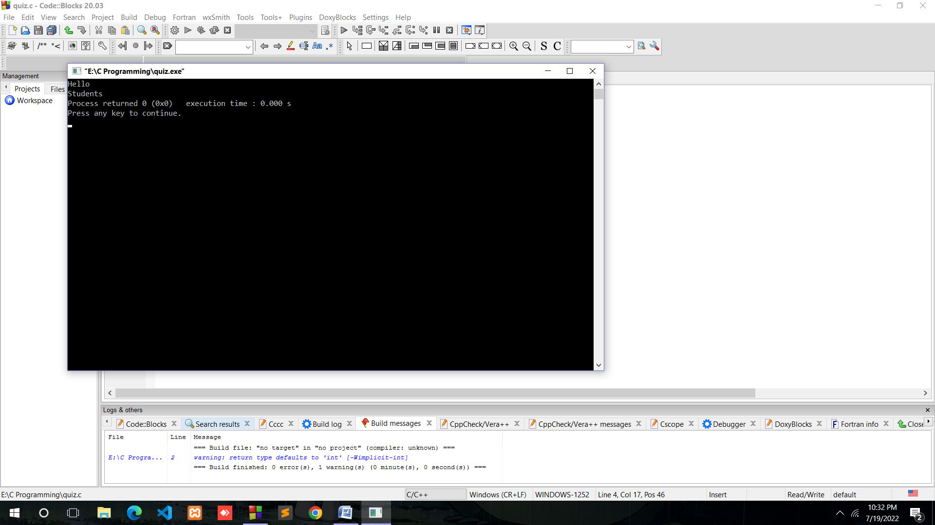

3. Write a C program to print “MySirG” on the screen.

Ans. Source Code:

#include<stdio.h>

main()

{

printf("\"MySirG\"");

}

Output:

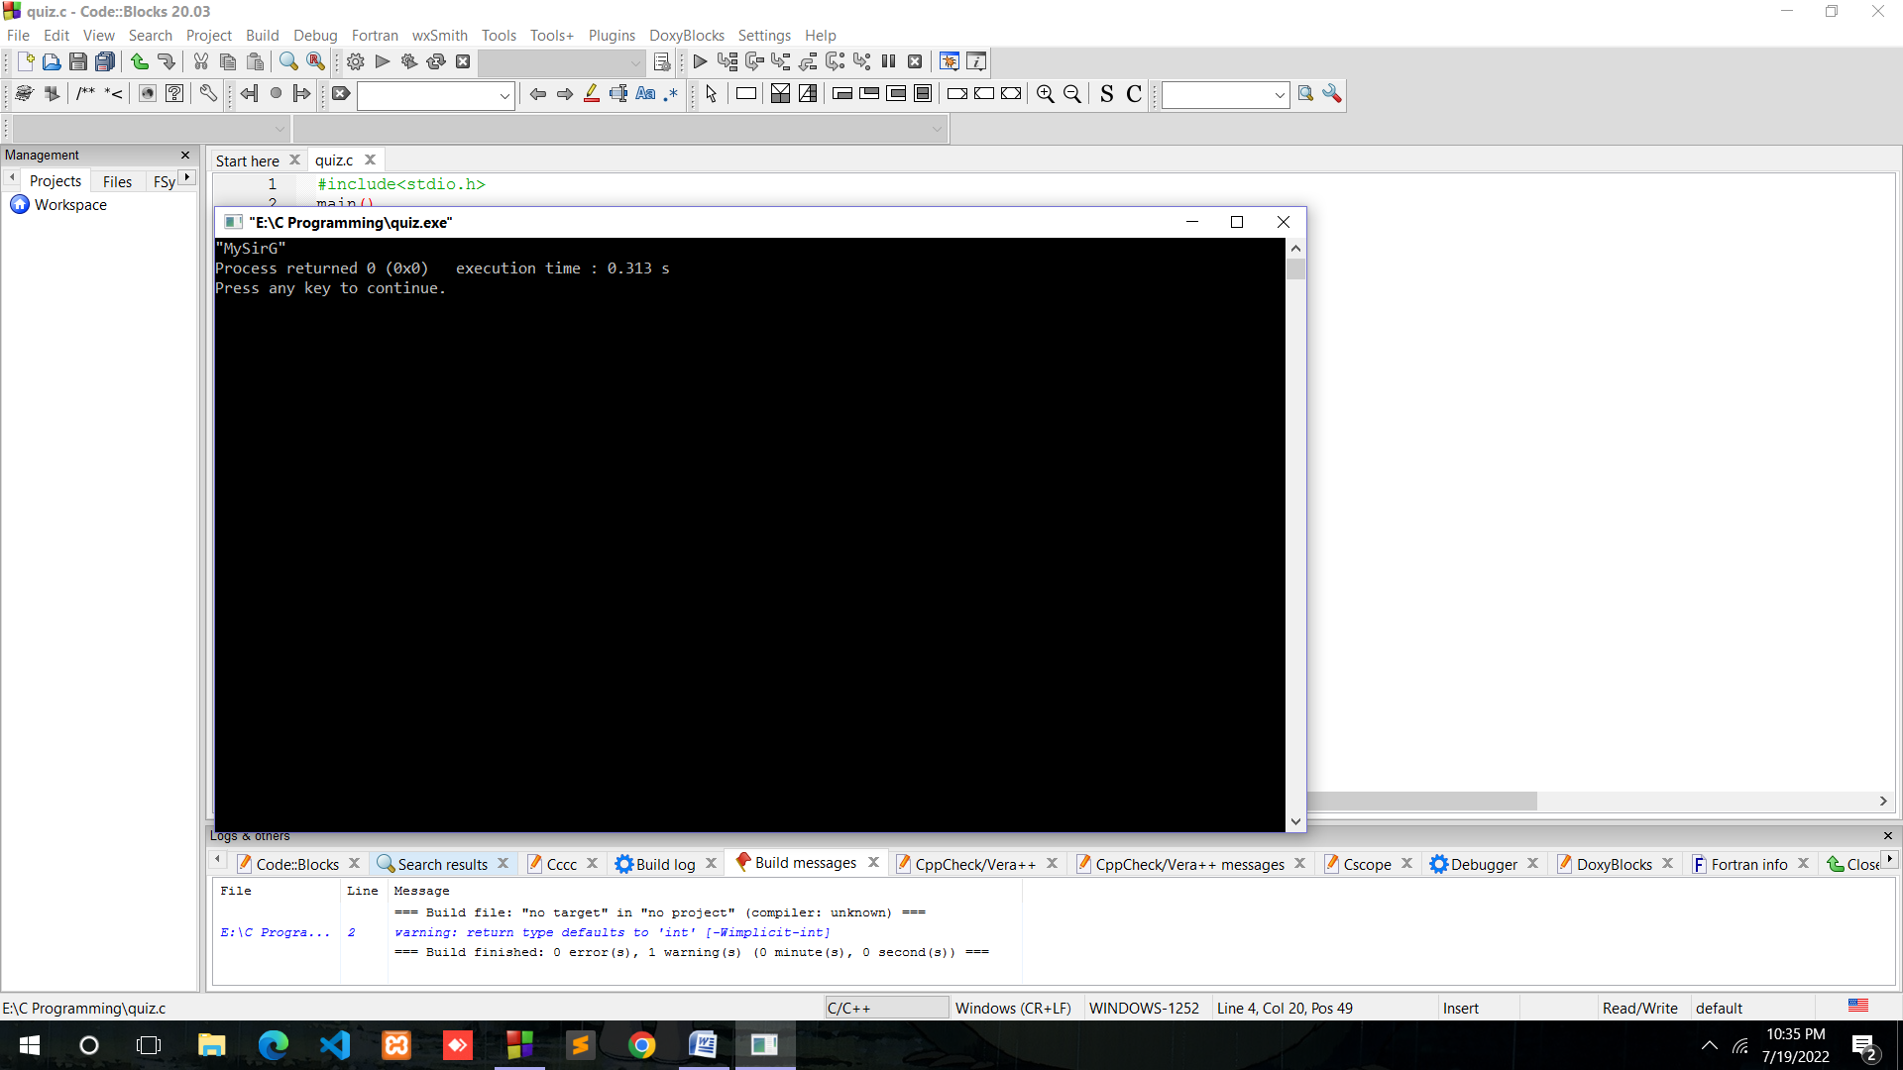

4. Write a C program to print “Teacher’s Day” on the screen.

Ans.

Source code:

#include<stdio.h>

main()

{

printf("\"Teacher\'s Day\"");

}

Output:

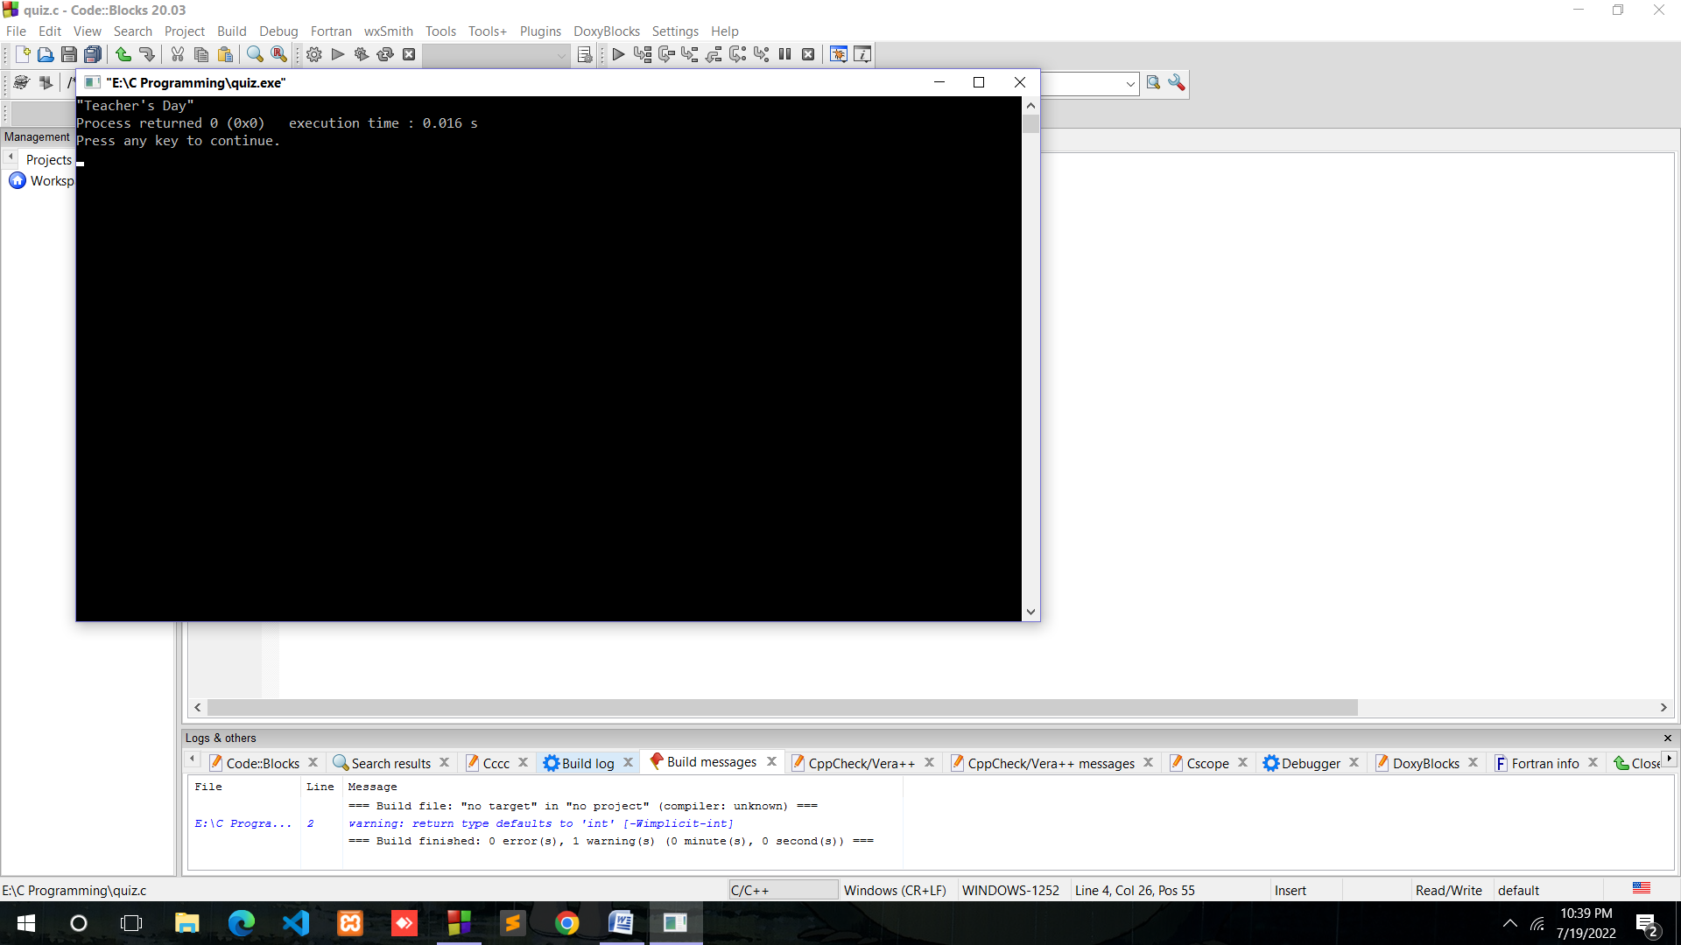

5.Write a C program to print \n on the screen.

Ans.

Source Code:

#include<stdio.h>

#include<conio.h>

main()

{

printf("\\n");

getch();

}

Output:

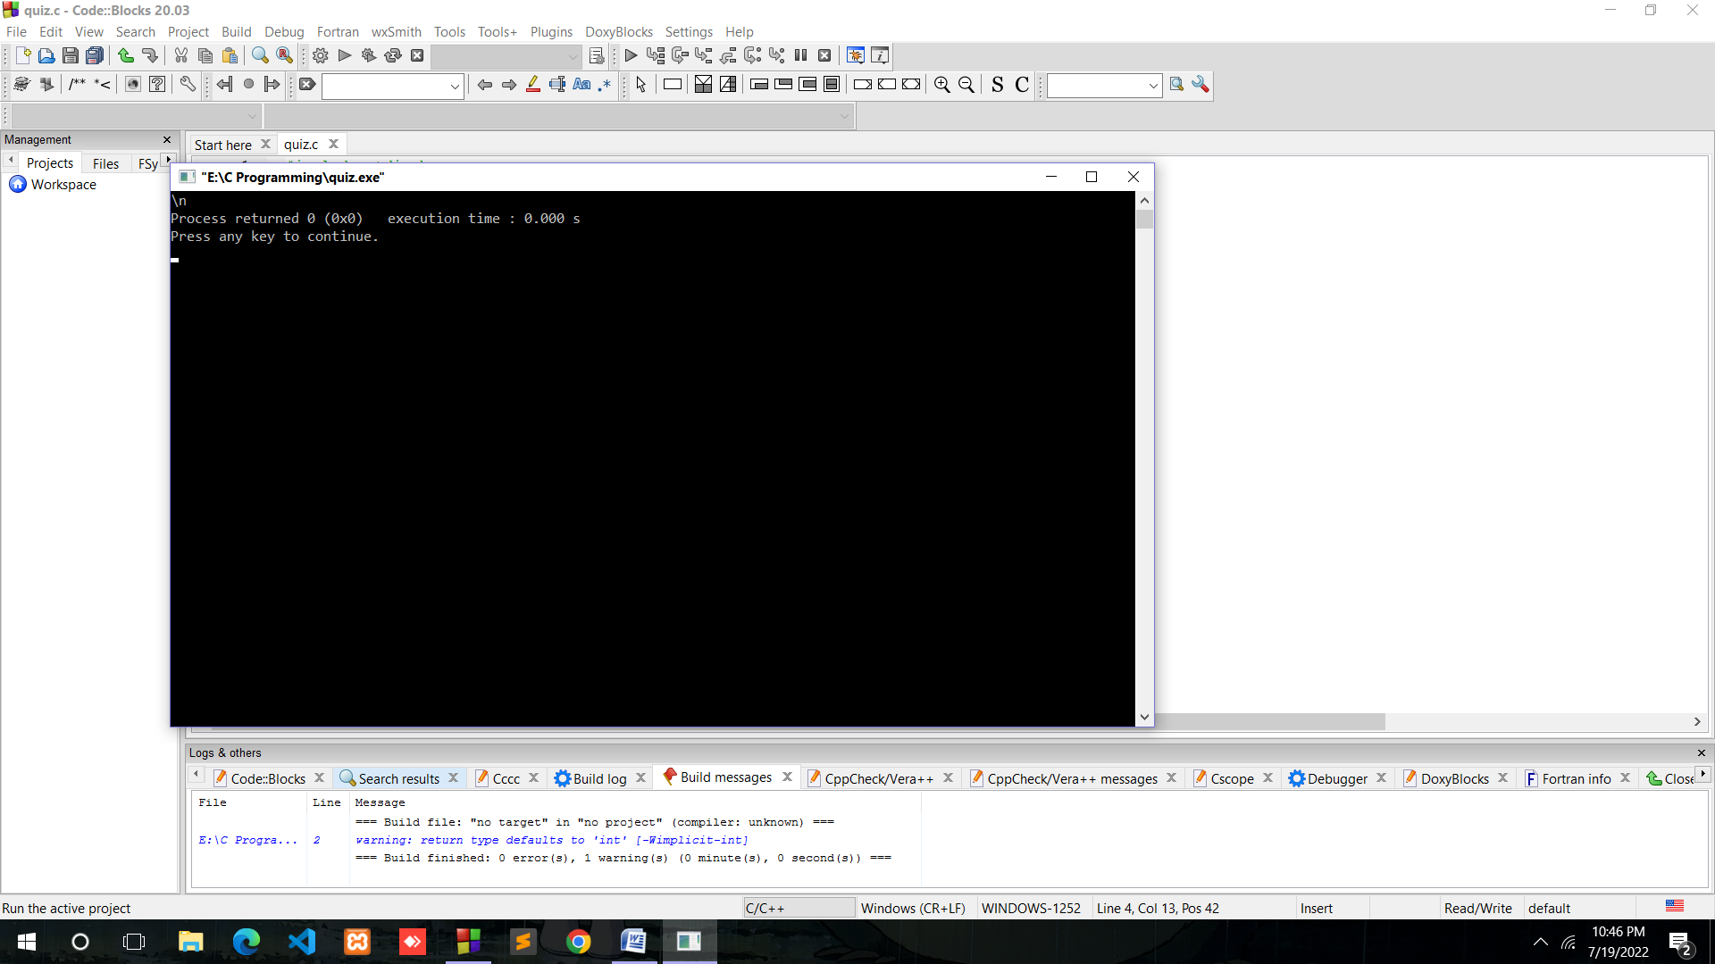

6. Write a C program to print %d on the screen.

Ans.

Source code:

#include<stdio.h>

#include<conio.h>

main()

{

printf("%%d");

getch(); }

Output:

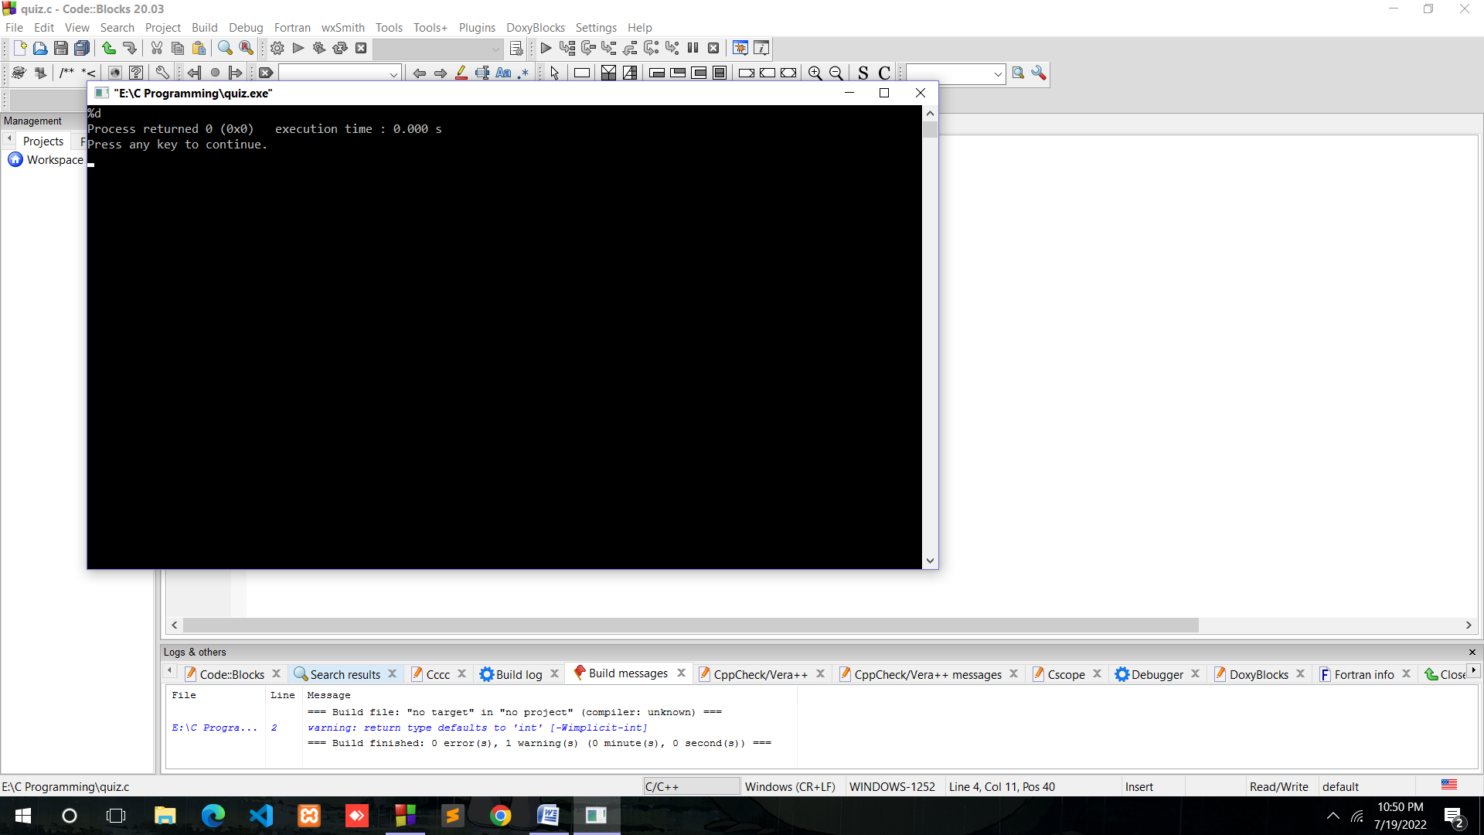

7. Write a C program containing declaration of three variables (of type int, char and float), also assign some values to them and print values of all three variables using single printf().

Ans:

Source Code:

#include<stdio.h>

main()

{

int a=5;

char b='I';

float c=7.5;

printf(" a=%d, b=%c, c=%f",a,b,c);

}

Output:

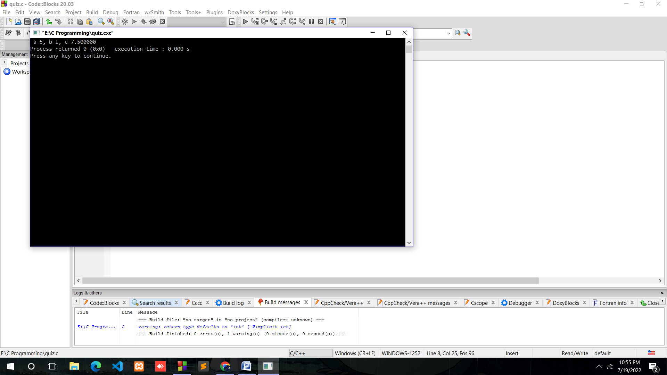

8. Explore following format specifiers on internet-%, %g. %If

Ans. A format specifier specify input or output’s format usually.

%i = unsigned interger

%g= scienctific notation

%lf= long type

9. Write a C program to print character stored in a char variable, also print its ASCII code.

Ans.

Source code:

#include<stdio.h>

main()

{

char a='A', b='B', c='c', d='D', e='e',f='F';

printf("a=%d,b=%d,c=%d,d=%d,e=%d,f=%d,",a,b,c,d,e,f);

}

Output:

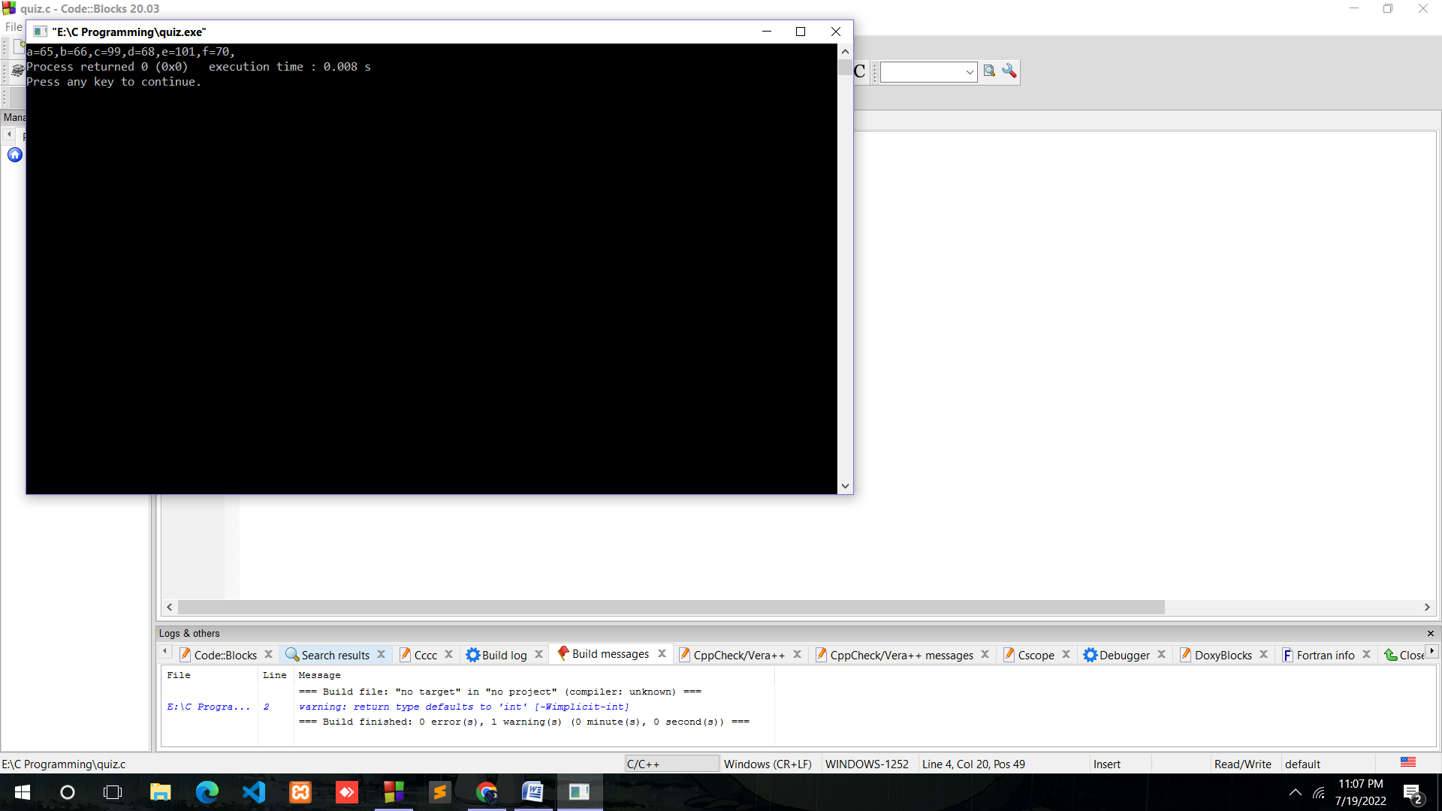

10. How to convert a Decimal number into a Binary number and vice versa.

Ans: To Convert a Decimal number to Binary:

An easy method of converting decimal to binary number equivalents is to write down the decimal number and to continually divide-by-2 (two) to give a result and a remainder of either a “1” or a “0” until the final result equals zero.

To Convert a Binary number ti Decimal:

The decimal number is equal to the sum of binary digits (dn) times their power of 2 (2n):

decimal = d0×20 + d1×21 + d2×22 + ...